**REPORT ON DEVOPS PROJECT**

**TITLE: IMPLEMENTATION OF ‘Web Application’ ON AWS**

# INTRODUCTION

In the ever-evolving realm of healthcare, where precision and organization are imperative for delivering superior patient care, the Hospital Management System project emerges as a transformative solution. Crafted with Django and deployed on AWS using Docker, this project stands at the intersection of technology and healthcare, seeking to revolutionize administrative and clinical processes within hospital settings.

At its core, this web-based application is a comprehensive tool meticulously designed to elevate the efficiency, accuracy, and accessibility of hospital operations. Leveraging the robust capabilities of Django, a high-performance Python web framework, the system offers a seamless and intuitive platform for managing diverse facets of hospital administration. From patient information and appointment scheduling to staff management and billing, every aspect of healthcare delivery is orchestrated with precision.

The deployment on AWS using Docker further enhances the project's adaptability and scalability. Docker's containerization technology ensures a consistent and isolated environment, facilitating easy deployment and management, while AWS provides a reliable and scalable infrastructure. This synergy between Django, Docker, and AWS encapsulates a vision for a modernized healthcare ecosystem, where technology augments the capabilities of healthcare professionals, ultimately translating to improved patient outcomes and an elevated standard of care. The Hospital Management System project signifies a pivotal step towards a more efficient, connected, and patient-centric healthcare landscape.

# KEY OBJECTIVES

1. **Efficient Collaboration:** Implement seamless communication and collaboration between development, operations, and other stakeholders to ensure a smooth workflow throughout the project lifecycle.
2. **Infrastructure as Code (IaC)**: Leverage IaC principles to define and manage the infrastructure required for the application. This ensures consistency, scalability, and easier maintenance of the environment.
3. **Monitoring and Logging**: Implement robust monitoring and logging solutions to proactively identify and address issues. This helps in maintaining a healthy application environment and improving overall system reliability.
4. **Containerization**: Utilize containerization (e.g., Docker) to enhance scalability, portability, and resource utilization of the Web application.
5. **Security Practices:** Prioritize security by incorporating best practices such as code scanning, vulnerability assessments, and role-based access control (RBAC) to protect both the application and its underlying infrastructure.
6. scalability and performance optimization to ensure the Web-application can handle increasing user loads efficiently.
7. By integrating these DevOps practices, we aim to deliver a reliable, scalable, and feature-rich Web-application, showcasing the power of collaboration and automation in software development.

# TECHNOLOGIES USED

* **AWS (Amazon Web Services) Instance**

o Provisioned EC2 instances to serve as scalable compute resources.

* + Configured security groups and networking settings to ensure a secure environment.
  + Used EC2 instances with t2-Micro configuration of VCPU’s (Virtual CPU) 1, RAM 1GB, Storage EBS-only (Elastic Block Store).
  + Operating System used in the virtual machine LINUX (Ubuntu).

* **Python** 
  + Installed and configured Python using Docker for building and executing applications.
  + Leveraging the power of Django, a high-level Python web framework, the system offers a robust and scalable platform for managing diverse aspects of hospital administration

**• MobaXterm**

* Installed on local machine and configured for accessing the virtual machine which is created on AWS.

* **DOCKER** 
  + Installed Docker to facilitate application containerization and ensure consistent deployment.
  + Used Docker to install the Django from Docker Hub.

# IMPLEMENTATION STEPS

1. **AWS EC2 Instances:**

**Provisioning:**

* + Launched AWS EC2 instances based on project requirements, considering factors such as instance type, storage, and region.
  + Configured the instances with appropriate Amazon Machine Images (AMIs) to support the desired operating system and pre-installed software.

**Security and Networking:**

* + Established security groups to control inbound and outbound traffic, ensuring a secure environment.
  + Configured Virtual Private Cloud (VPC) settings to isolate the network and control communication between instances.

**Operating System:**

* Used Linux (Ubuntu) as an operating system .

1. **Python Installation:**

o Installed the Python (Django) on the EC2 instances using Docker to enable Web-based development.

o Configured environment variables to ensure proper execution of Java applications.

1. **DOCKER Integration:**

o Installed Docker on the EC2 instances to enable containerization.

* + - Configured Python to build Docker images based on the application code and dependencies.
    - Utilized Docker file for defining the application environment within the containers.

# BENEFITS AND OUTCOMES

1. **Faster Time-to-Market:** 
   * Benefit: DevOps automates and streamlines the development and deployment processes, reducing manual interventions.
   * Outcome: Quicker and more reliable releases, enabling the Web app to reach users faster with new features and updates.

1. **Increased Collaboration and Efficiency:** 
   * Benefit: DevOps promotes collaboration between development, operations, and other teams.
   * Outcome: Improved communication, faster issue resolution, and enhanced overall efficiency as teams work cohesively to deliver and maintain the Web-Application.

1. **Higher Quality and Reliability:** 
   * Benefit: Automated testing and continuous integration ensure code quality is maintained throughout the development cycle.
   * Outcome: Fewer bugs, increased reliability, and a more stable Web-app that meets user expectations and minimizes downtime.

1. **Improved Scalability and Flexibility:** 
   * Benefit: Infrastructure as Code (IaC) and automation allow for scalable and flexible deployment architectures.
   * Outcome: The Web-app can easily adapt to changing user demands and handle increased workloads efficiently.

**OUTCOMES:**

Following are some of the image build and running on Aws:

* **Image of AWS EC2 Dashboard**

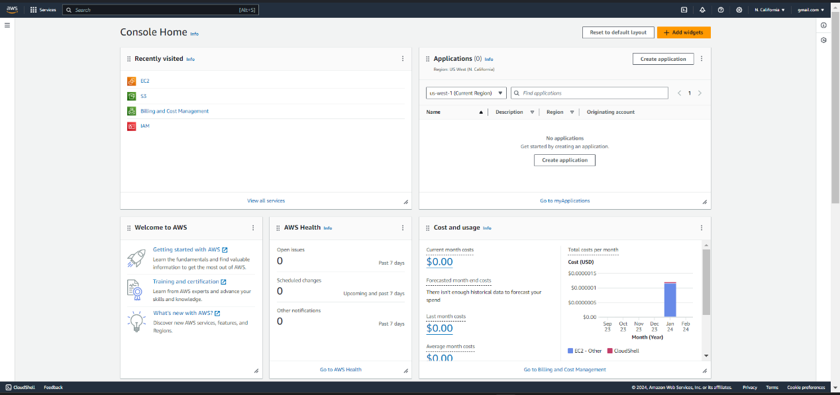

**◉ MobaXterm Interface**

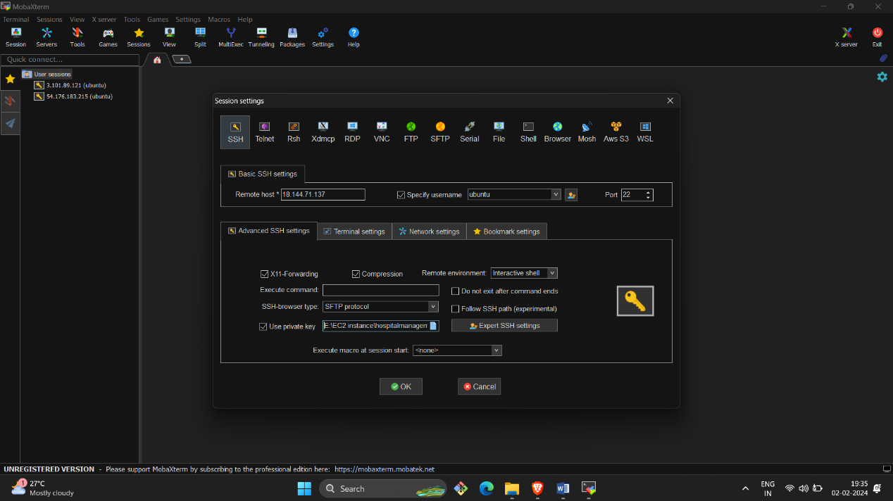

**◉ MobaXterm creating HTML and CSS file with the help of LINUX Commands**

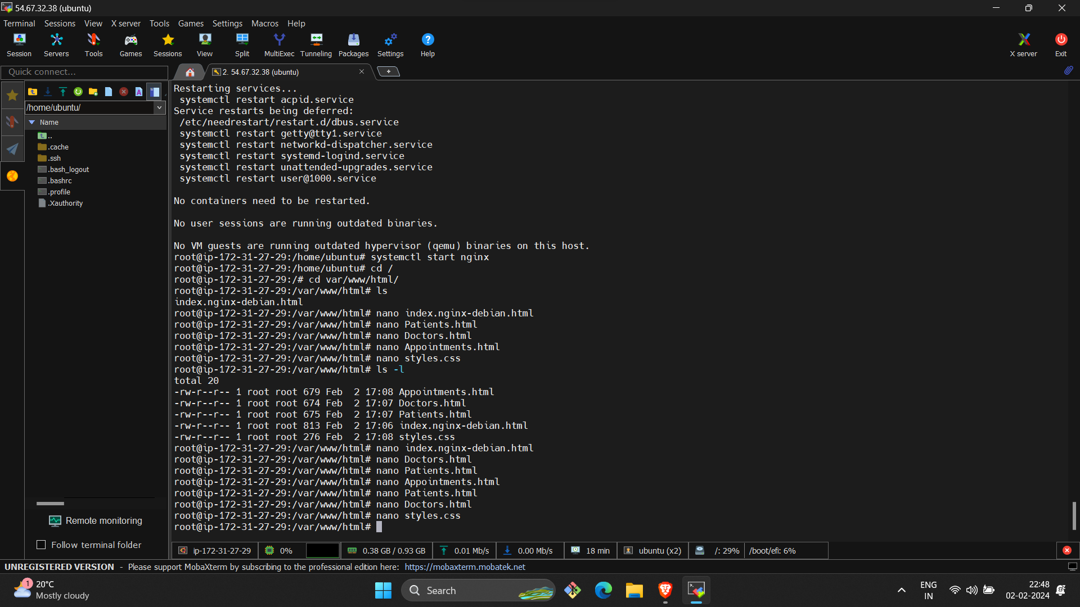

**◉ Install Nginx for Deploying the Web-Application**

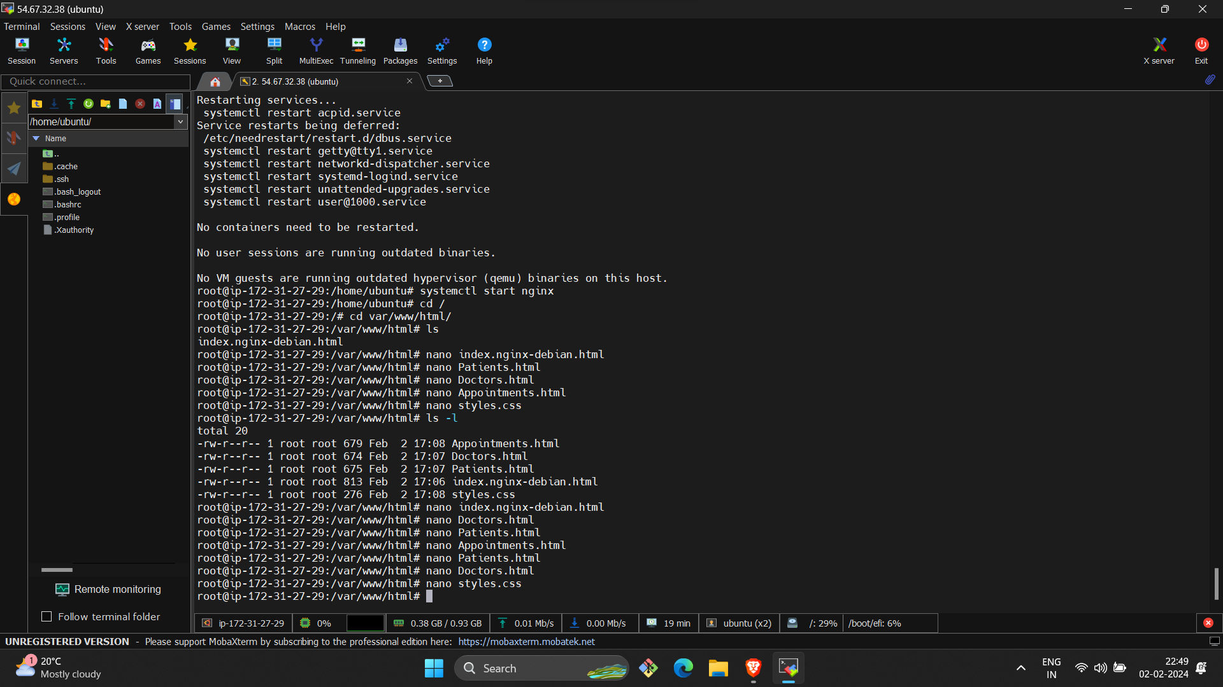

◉ **Interface of the Hospital Management System**

**◇ Accessed by VM’s IP address provided by AWS**

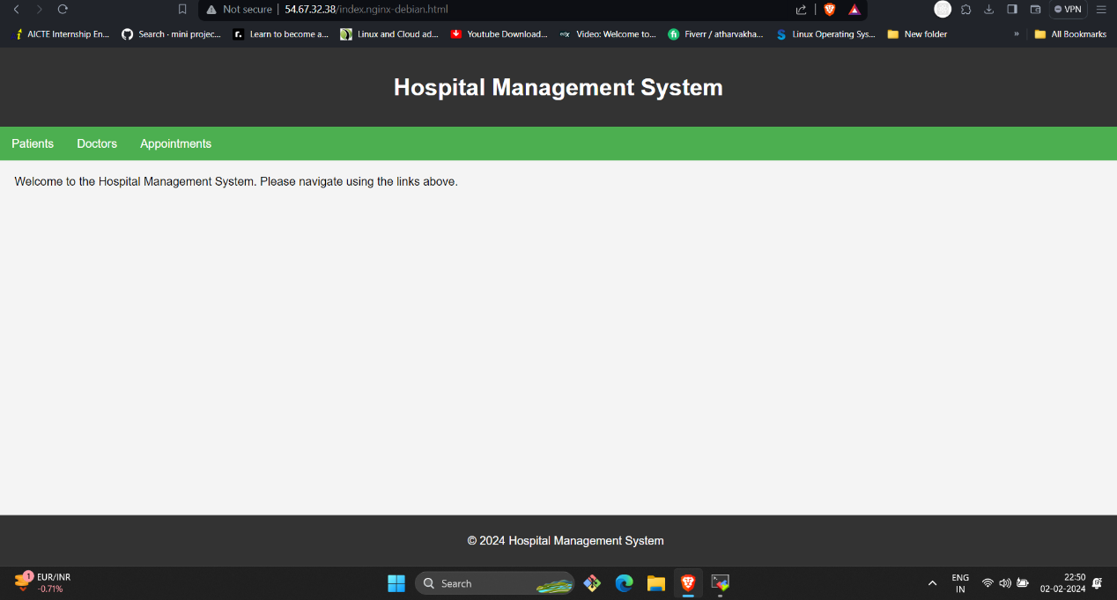

**◉ Routing through the links provided**

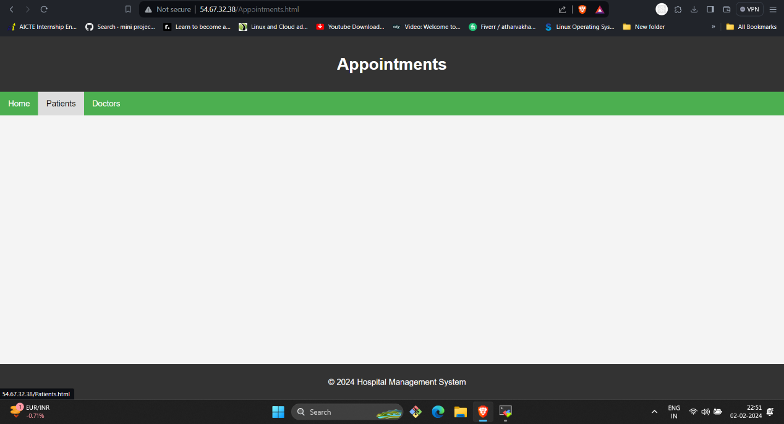

1. **CHALLENGES AND SOLUTIONS:**

**i. Monitoring and Logging:**

* + - * Challenge: Identifying and resolving issues quickly to ensure optimal app performance.
      * Solution: Implementing robust monitoring and logging solutions to track system behaviour and troubleshoot problems effectively.

**ii. Scalability:**

* + - * Challenge: Ensuring the app can handle increased loads and scale horizontally.
      * Solution: Designing scalable architectures, utilizing containerization (e.g., Docker), and employing auto-scaling mechanisms.

* 1. **Security:**

* + - * Challenge: Protecting sensitive user data and preventing vulnerabilities.
      * Solution: Conducting regular security audits, implementing encryption, and following best practices for secure coding.

* 1. **Collaboration and Communication:**

* + - * Challenge: Ensuring effective communication and collaboration among development, operations, and other teams.
      * Solution: Using collaboration tools, establishing clear communication channels, and fostering a DevOps culture.

* 1. **Dependency Management:**

* + - * Challenge: Handling dependencies and ensuring consistent environments across different stages.
      * Solution: Utilizing dependency management tools (e.g. Python, Django) and containerization to encapsulate dependencies.

* 1. **Testing Strategies:**

* + - * Challenge: Guaranteeing the reliability and functionality of the app through various testing scenarios.
      * Solution: Implementing automated testing, including unit tests, integration tests, and end-to-end tests, to catch issues early in the development process.

1. **CONCLUSION:**

In conclusion, the DevOps implementation for the Web-app project has significantly enhanced collaboration between development and operations teams. Automated testing has improved code quality, and infrastructure as code (IaC) practices have made deployment consistent and scalable. Monitoring and logging tools provide real-time insights, enabling proactive responses to issues. Overall, this DevOps initiative has increased efficiency, reduced downtime, and fostered a more collaborative and agile development environment for the Web-app.

**REFERENCES:**

**GitHub repository link** https://github.com/sumitkumar1503/hospitalmanagement.git